ÖZYEĞİN UNIVERSITY ETHICS REVIEW APPLICATION SYSTEM
Applicant Guide (Graduate Students, Academics & Doctoral Students)
1. System Login and Overview
The Özyeğin University Ethics Review Application System digitally manages the ethics approval processes for research involving human participants.
- Access Address: https://etikkurul.ozyegin.edu.tr/ Login Method: Sign in with your Özyeğin account (@ozyegin.edu.tr / @ozu.edu.tr) using Microsoft SSO (Single Sign-On).
- Authorization Rule: Only academic staff and graduate students (master’s and doctoral) are authorized to access the system. The system will display a warning if access is attempted with an unauthorized account.
- Test and Development Environment: Corporate SSO is used for access.
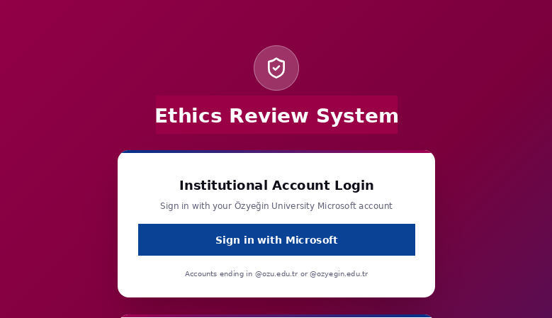
2. Home Page (Dashboard)
The dashboard is displayed after a successful login and allows you to monitor the status of your applications from a single screen.
- Statistics Cards: Display real-time counts of total, pending, approved, and rejected applications.
- New Application Quick Access: Provides shortcut buttons for starting a new Ethics Committee application.
- Drafts: Provides quick access to incomplete or not-yet-submitted applications.
- Recent Applications: Lists the status of recent applications (e.g., Under Ethics Committee Review, Approved, Revision Requested, In EBYS Signature Process) together with their latest update dates.
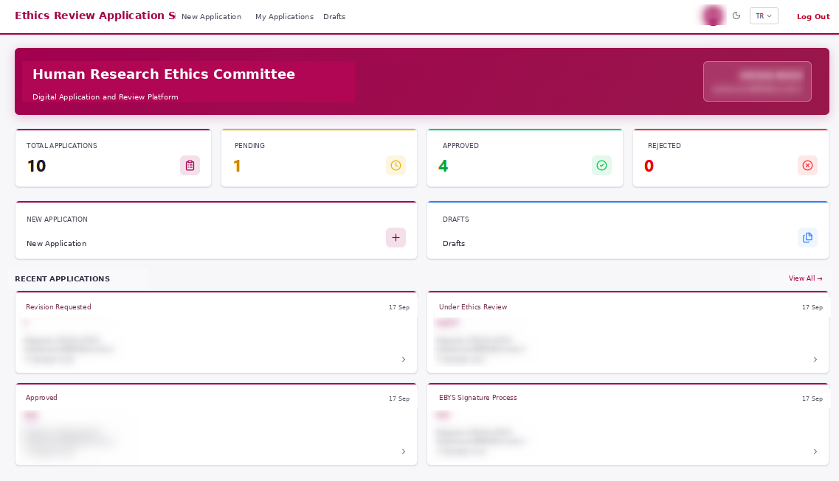
3. Ethics Review Application Form
This is the main form used to create a new application or complete an existing draft. The form consists of five main sections:
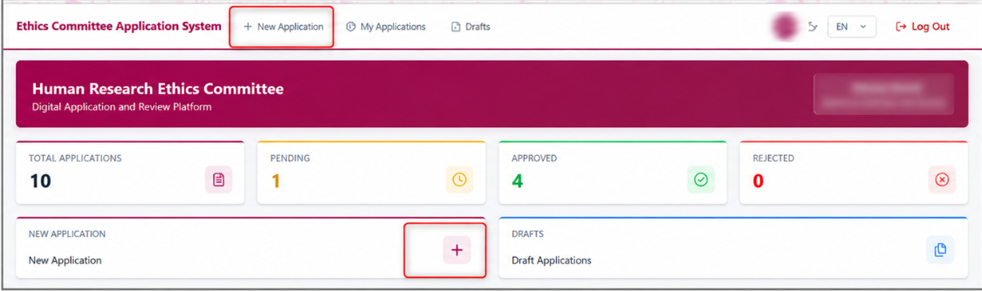
A. Project Information
- Project Title: Enter the full title of the project in both Turkish and English.
- Abstract: Provide an abstract of no more than 300 words describing the purpose, methodology, and significance of the study.
- Is This a Thesis?: Select whether the study is a thesis project (Yes / No).
📌 APPROVAL WORKFLOW BASED ON THESIS STATUS: If 'No' is selected for 'Is This a Thesis?': Even if supervisor information is provided, the application is sent directly to the Ethics Committee without supervisor approval.
If 'Yes' is selected for 'Is This a Thesis?': The application is first sent to the thesis supervisor for approval. After approval, it is forwarded to the Ethics Committee for review.

B. Project Personnel
- Principal Investigator (PI): The full name and e-mail address of the person responsible for the research are automatically populated by the system or entered as applicable.
- Other Researchers: Use the '+ Add Researcher' button to add other researchers involved in the project.
C. Research Protocol
- Timeline: Select the start and end dates of the data collection period.
- Methodology: Describe the data collection and analysis methods.
- Participants: Specify the number of participants, demographic characteristics, and inclusion/exclusion criteria.
- Participant Recruitment Process: Explain how participants will be identified and invited to take part in the study.
- Compensation for Participants: Specify any payment, gift, gift card, or other compensation to be provided.
- Informed Consent: Describe in detail how participants will be informed and how consent will be obtained before the research begins.
- Data Collection: Explain how data will be collected, stored, and protected to ensure confidentiality.
D. Key Ethical Considerations
- Applicable Ethical and Legal Guidelines: Specify the ethical principles and legal requirements that will govern the research.
- Research Data Management and Publication: Explain how the data will be managed and published and how the research results will be communicated.
- Deception: State whether deception will be used in the study.
- Risk of Harm: Describe any potential risks to participants or researchers and the measures that will be taken to mitigate them.
- Debriefing: Explain how participants will be informed or debriefed at the end of the study.
E. Project Management and Supporting Documents
- Funding Source: Specify the organization and source of financial support for the research (e.g., ÖzÜ, TÜBİTAK, self-funded).
- Supporting Documents & Informed Consent Form: Upload all required supporting documents and Informed Consent Forms to the system.
- Declaration and Confirmation: Select the declaration checkbox confirming compliance with ethical principles and complete the Faculty/Institute, Telephone, and Date fields.
Accepted File Formats and Limits
File Type | Supported Formats | Maximum Limit
Documents & Text | Word (.doc, .docx), PDF, Text (.txt) | 10 MB / file
Image Files | Image (.png, .jpg, .jpeg) | 10 MB / file
Total Number | Across All Fields | Maximum 10 files

Form Action Buttons
- Cancel: Exits the form without saving changes.
- Save as Draft: Saves the information entered so that you can continue the application later.
- Submit Application: Sends the completed form into the approval workflow (Supervisor or Ethics Committee) for review.
4. My Applications (Application Tracking)
This screen allows you to monitor, filter, and review the current status of all submitted applications.
- Tab Options: Applications can be filtered by status: Revision Pending, In Progress, Completed, and All.
- Search and Filtering: Dynamic searches can be performed by Application ID, Project Title, Status, Application Date, and Last Modified Date.
- Export to PDF: Allows you to download the summary and form content of the relevant application to your computer in PDF format.
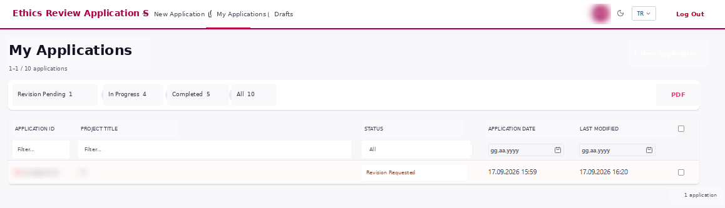
5. Revision History and Review Comments
When your Supervisor or the Ethics Committee requests changes to your application, the 'Revision History' sections become active on the application details screen. These sections allow you to transparently track the feedback received at each stage of the application:
- Ethics Committee Revision History: Lists feedback and revision requests submitted by Ethics Committee members/reviewers. Each comment is displayed together with the relevant item number (e.g., 1. Project Title, 6. Methodology).
- Supervisor Revision History: For thesis applications, displays notes and revision requests entered by the thesis supervisor during the review stage (e.g., 14. Deception, 16. Debriefing).
- Round and Comment Statistics: Labels shown next to the heading (e.g., 1 round - 2 comments) indicate the current revision round and the total number of comments entered.
- Direct Mapping to Form Items: Feedback is listed against the corresponding headings and item numbers in the application form, allowing the researcher to quickly identify which fields require revision.
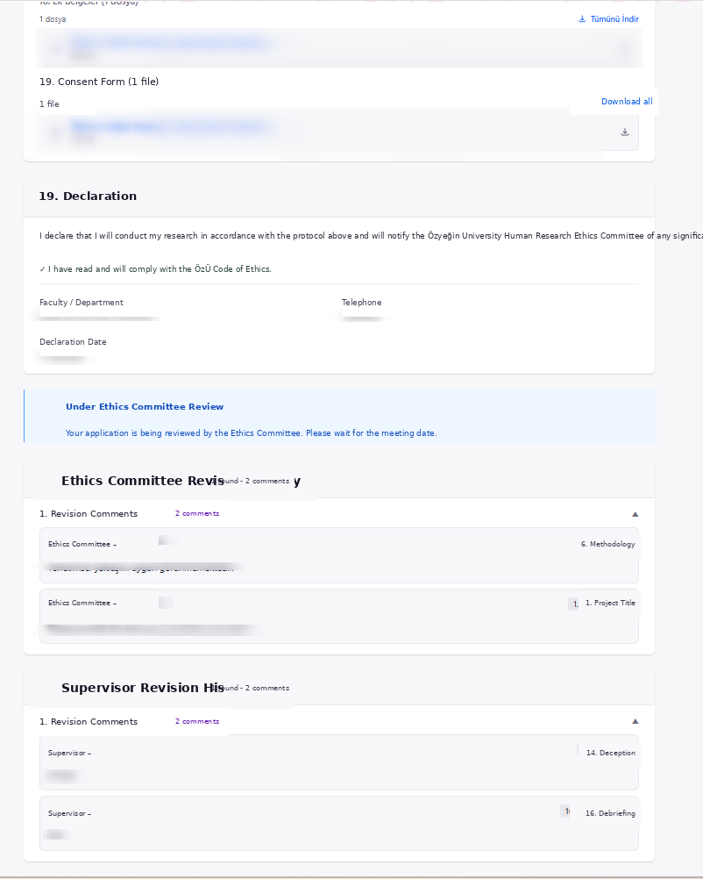

6. Drafts Screen
This section lists applications that are still being prepared and have not yet been submitted to the Committee.
- Search and Listing: Saved drafts can be searched by Project Title and Last Updated Date.
- Edit and Submit: A draft selected from the list can be opened, completed from where you left off, and submitted.
- New Application Button: A new application can also be started directly from this page.
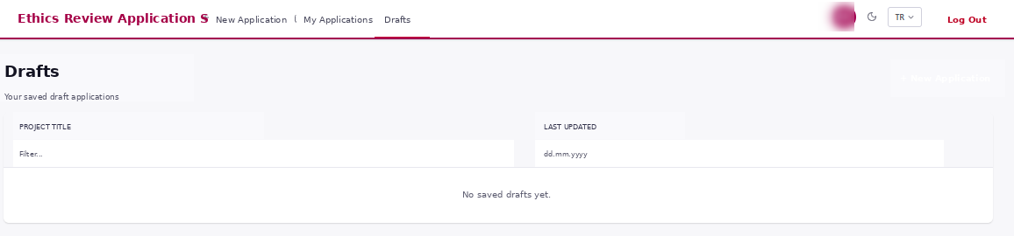
7. E-mail Notifications and Application Status Updates
The Ethics Review Application System automatically notifies the applicant researcher and relevant parties by e-mail at each stage of the application process. The main types of system-generated e-mail notifications are as follows:
- Application Received / Process Started Notification:Sent to the applicant researcher when the application form is successfully submitted. For thesis applications, the notification states that the application has been sent for supervisor approval; for other applications, it states that the application has been sent directly for Ethics Committee review.
- Approval Notification (Approved):Once the Ethics Committee review is complete and the application is approved, the applicant receives the approval information and details of the Committee decision by e-mail. If the Committee has approved the application and the process is fully complete, or if the study does not require secondary data, the official EBYS-approved document will be attached to the notification e-mail in PDF format.
- Revision Request Notification (Revision Requested):If the thesis supervisor or Ethics Committee requests changes to the application, the reasons for revision and the items requiring review are communicated by e-mail. The applicant can sign in to the system and make the necessary updates.
- Rejection Notification (Rejected): If the Ethics Committee determines that the application is not suitable and rejects it, the rejection decision and its rationale are communicated by e-mail.

