ÖZYEĞİN UNIVERSITY ETHICS REVIEW APPLICATION SYSTEM
Thesis Advisor User Guide
1. System Login and Overview
This guide explains the review, approval, rejection, and revision actions performed by thesis advisors for ethics applications submitted as part of a thesis study.
- Access URL: https://etikkurul.ozyegin.edu.tr/
- Login Method: Sign in via Microsoft SSO using your Özyeğin University institutional account (@ozyegin.edu.tr / @ozu.edu.tr).
- Role-Based Access: When signed in with the Advisor role, advisor-specific menus and evaluation pages are displayed.
Important: Advisor review applies to thesis-related applications. Once approved by the advisor, the application is forwarded to the Ethics Committee for review.
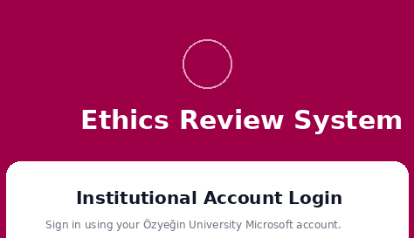
2. Advisor Dashboard and Navigation
After login, the advisor can use the role-specific dashboard to track applications awaiting review from assigned students and to access previous actions.
- Pending Approvals: Lists student applications awaiting advisor approval.
- Approved by Me: Provides access to applications previously approved by the advisor.
- Revision Requested: Tracks applications for which the advisor has requested revisions.
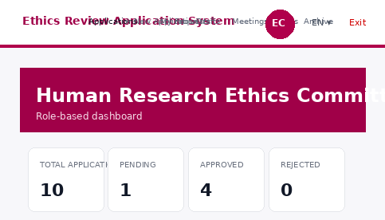
3. Viewing Pending Approvals
The “Pending Approvals” page displays only applications submitted by the advisor’s assigned students that are currently in “Awaiting Advisor Approval” status. Records are listed from the most recent submission to the oldest.
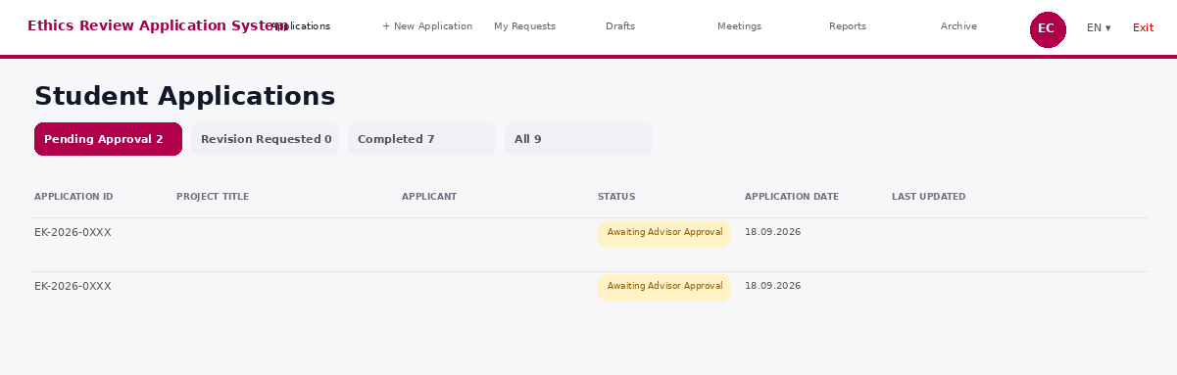
Field | Description
Application ID | Unique tracking number assigned to the application
Student Name | Name of the graduate student submitting the application
Project Title | Title of the research submitted for ethics review
Submission Date | Date on which the application was submitted for advisor review
Review | Opens the application details and decision page

4. Reviewing an Application
Selecting “Review” opens the application evaluation page. All application fields are displayed in read-only mode; supporting documents can be downloaded, and relevant fields can be selected when a revision is required.
- Application Details: Review the project information, researchers, research protocol, ethical considerations, project management, and declarations.
- Attachments: The informed consent form and other supporting documents can be opened or downloaded.
- Decision Panel: APPROVE, REQUEST REVISION, and REJECT actions are performed from this panel.
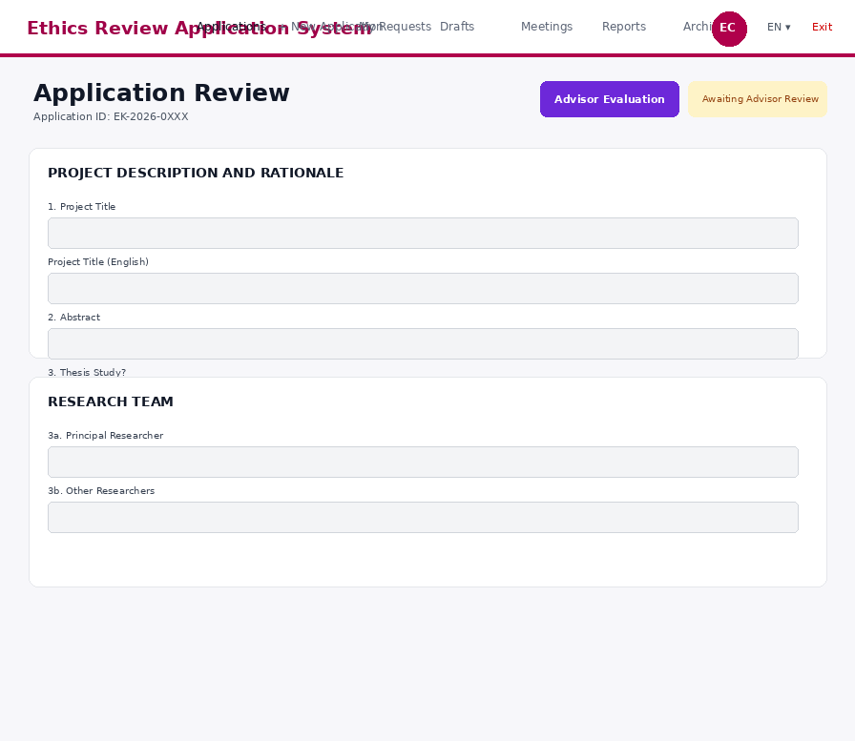
5. Advisor Decisions
A. APPROVE
When APPROVE is selected, the system requests confirmation. An optional note may be added. After approval, the application status changes to “Under Ethics Committee Review,” and the student is notified automatically by e-mail.
B. REJECT
For a rejection, the “Reason for Rejection” field is mandatory and must contain at least 50 characters. Once rejected, the application is closed; the reason is sent to the student by e-mail, and a new application must be submitted if the process is to continue.
Important: A rejection cannot be reversed.

C. REQUEST REVISION
When revision mode is enabled, select the application field requiring correction and add a field-specific comment. Comments may be added to multiple fields. The “Send Revision Request” action becomes available after at least one comment has been entered.
6. Adding Revision Comments and AI Assistance
- Field Selection: Select the application field that requires correction.
- Comment: Enter a free-text explanation for the selected field.
- Sample Text: Where available, predefined comment templates may be used.
- AI Preview: A professionally refined, academic-language version of the comment is displayed for preview.
- Submission: Once all comments are complete, send the revision request to the student.
Timing Rule: There is no time limit for the advisor revision cycle; the application may be revised as many times as necessary.
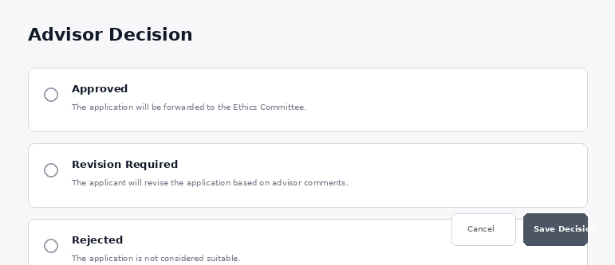
7. Process After Revision
After the student completes the requested changes and resubmits the application, the advisor can review it again. The revision cycle may continue until the advisor approves the application. Following advisor approval, the application is forwarded to the Ethics Committee for evaluation.
8. E-mail Notifications
After an advisor decision is recorded, the system automatically notifies the relevant users. Approval notifications state that the application has been forwarded to the Ethics Committee; rejection notifications include the reason for rejection; and revision notifications identify the items requiring correction.

