THESIS AND DISSERTATION PREPARATION GUIDELINES

GRADUATE SCHOOL OF SOCIAL SCIENCES

ÖZYEĞİN UNIVERSITY
JANUARY 2024

TABLE OF CONTENTS
FOREWORD 1
1. FORMATTING AND APPEARANCE 2
1.1 Margins 2
1.2 Font Type and Size 2
1.3 Line Spacing 5
1.4 Centering and Alignment 5
1.5 Pagination 6
1.7 Headings 7
1.8 Numbering 7
2. FORMAT OF THE TABLES FIGURES AND FOOTNOTES 9
2.1 Tables and Figures 9
2.2 Illustrations 10
2.3 Footnotes 11
3. PARTS OF A THESIS 12
3.1 Order of the Parts 12
3.2 Preliminary Pages 13
3.2.1 Title Page 13
3.2.2 Approval Page 14
3.3.3 Dedication Page 14
3.3.4 The Declaration of Originality 14
3.3.5 Abstract and Keywords 15
3.3.6 Acknowledgments 15
3.3.7 Table of Contents 16
3.3.8 List of Tables, Figures, Symbols, Acronyms and Abbreviations 16
3.4 The Main Text 16
3.5 References or Bibliography 17
3.6 Appendices 18
3.8 Vitae 18
4. THESIS BINDING 19
4.1 Printing 19
4.2 Signatures 19
4.3 Properties of the Cover of the Thesis/Dissertation 20
4.3.1 Spine Layout 20
4.3.2 Cover Layout 20
4.2.3 Color Code and Material of the Cloth 20
4.2.4 Lettering on the Cover and the Spine 20
APPENDICES 21
APPENDIX A. A SAMPLE SPINE 22
APPENDIX B. A SAMPLE COVER PAGE 23
APPENDIX C. A SAMPLE VITAE 24

FOREWORD
This guideline aims to help graduate students at Özyeğin University to write and format their master’s theses or doctoral dissertations in accordance with certain standards and rules that will ensure precise and rigorous presentation of their work as well as consistency of the theses and dissertations written at Özyeğin University. A master’s thesis work is called a “thesis” while a doctoral work is called a “dissertation”. For convenience of expression the word “thesis” will be used in this document to refer to both master’s and doctoral thesis.
The formatting standards and rules presented in this guideline have been prepared in accordance with the Publications Manual of American Psychological Association (APA) Version 7, although there are very few deviations from the APA format. The referencing systems, however, differ with respect to fields. The Sample Thesis Template prepared for each field guides the candidates on the referencing system, and field-specific formats they should use in their thesis. Candidates are strongly encouraged to read the guidelines to ensure compliance with the standards and avoid unnecessary delays in their graduation. Please do not use a previously written thesis as a template as their formatting might be different from the updated versions of the standards of formatting described in this guideline. The guidelines are supplemented with a Sample Thesis Format prepared for each faculty or department, and a Thesis Format Checklist. Please ensure that you check the format of your thesis using the checklist. For any issues that have not been covered in this guideline, in the Publications Manual of APA version 7, and in the Sample Thesis Format, please ask the
Graduate School of Social Sciences for clarification.

1. FORMATTING AND APPEARANCE
This chapter presents the formatting rules of the different parts (the main body, tables, figures, footnotes, etc.) of a thesis text. Please make sure that the different components of the text comply with the rules consistently throughout the thesis.

1.1 Margins
The margins throughout the manuscript should be as follows:
Left: 3.5 cm (to allow for binding)
Top: 3.5 cm
Bottom: 2.5 cm
Right: 2.5 cm
Header and Footer: 1.25 cm
Please make sure that pages in landscape orientation have 3.5 cm at the top to allow for binding. It is recommended that you set the margins at the beginning. Alternatively, you may use the Sample Thesis Format as a template. All content of the thesis, including the main text, headings, tables, figures, equations, illustrations, and page numbers should be within the margins. To set up the margins in Word, click on Layout, Margins, and Custom Settings, respectively. The margin setup should look similar to the one depicted in Figure 1.1.

1.2 Font Type and Size
- Font type. Times New Roman should be used throughout the thesis. Please make sure that no other font is used in the thesis.
- Font size. Font sizes for different levels of headings, the main text, notes, and footnotes, and the content of tables and figures are given in Table 1.2.1. The font sizes (as given in Table 1.2.1) should be consistent throughout the thesis.
- Boldface letters and italics may be used for special emphasis and foreign words.
Figure 1.1 Setting up Margins in Word
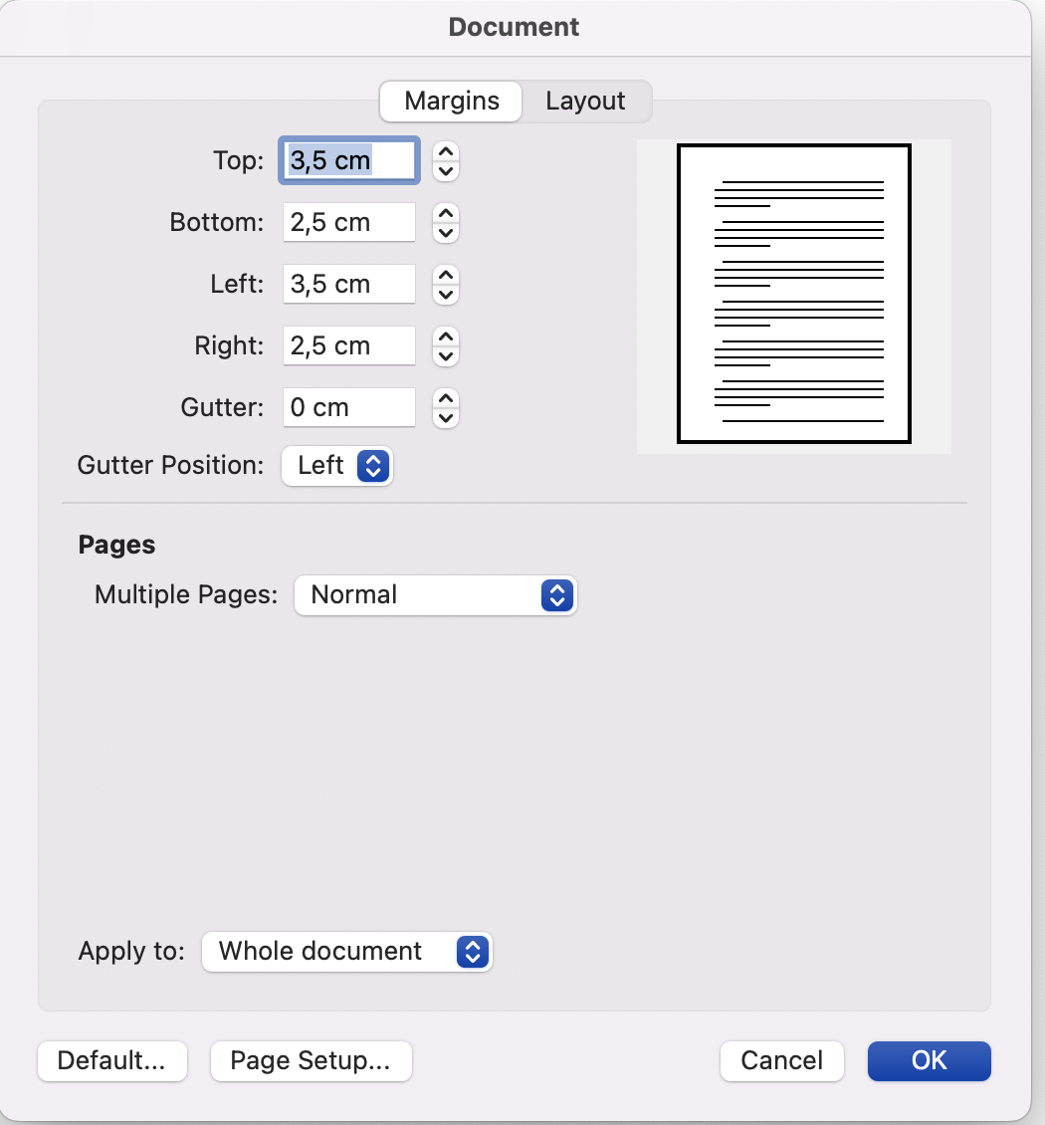 | 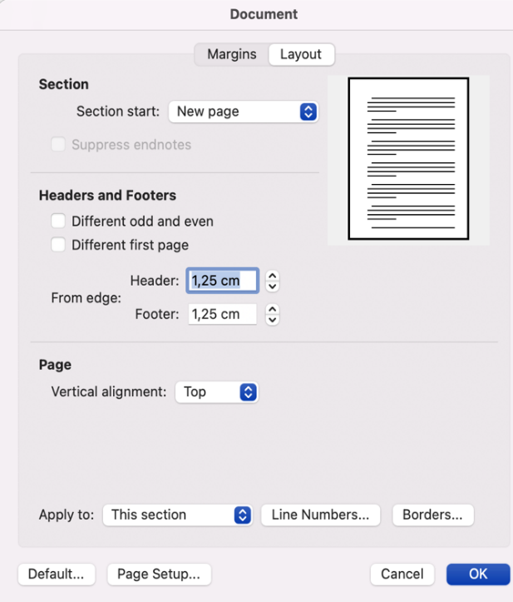
Note. Please note that in different versions of Word, there may be differences in the interface.
Table 1.2.1 Font Sizes and Spacing for Different Types of Texts in a Thesis
Type of Texts | Font Size | Spacing
Title of the thesis | 15 pt. | Single
Level 1 heading (Section labels) | 12 pt.  12 pt.  12 pt.  12 pt. | Double; there is 12 pt. space below the Level 1 heading and the text.  Double; there is 12 pt. space before Level 2, 3, and 4 headings. There is no extra space after Level 2, 3, and 4 headings.
Level 2 headings
Level 3 headings
Level 4 headings
Dedication page | 14 pt. | Double
Declaration of Originality | 12 pt. | Double
Table of Contents; List of Tables, List of Figures, List of Acronyms and Abbreviations, List of Symbols | 12 pt. | One-and-a-half
The main text, dedication page, Acknowledgements, Abstract, Özet | 12 pt. | Double
References list | 12 pt. | Double
Table titles and figure captions | 12 pt. | Double if there is more than one line. There is 12pt. space before and after a table title and figure caption, and at the end of the table or a figure (if there is a note, the 12 pt. space should be after the note).
Footnotes, notes to figures and tables | 10 pt. | Single
The content of the tables | Can be 12, 11, 10, 9 or 8 pt.; but should be consistently used across tables | Can be double-, single- or one-and-a-half spaced; but should be consistently used across tables.
The content of the figures | Can be 12, 11, 10, 9 or 8 pt.; but should be consistently used across figures | Can be double-, single- or one-and-a-half spaced; but should be consistently used across figures.
Equations | 12 pt. | Single-spaced if there are multiple equations. There is 12pt. space before and after equations and the text.

1.3 Line Spacing
- Abstract, Özet, the main text, and the References list are double-spaced. For spacing rules for different texts in the thesis see Table 1.2.1.
- Table and figure notes and footnotes are single-spaced. For details of the spacing
within the Tables and Figures, and before and after tables and figures see Table 1.2.1.
- Leave 12 pt. space after Level 1 headings.
- Leave 12 pt. before Level 2, 3, and 4 headings.
- Do not leave extra spacing between paragraphs.

1.4 Centering and Alignment
- All section headings (i.e., Level 1 headings such as ABSTRACT, ÖZET, TABLE OF CONTENTS, LIST OF TABLES, LIST OF FIGURES, LIST OF ABBREVIATION AND SYMBOLS, CHAPTER (SECTION) TITLES, REFERENCES, APPENDICES, APPENDIX A, APPENDIX B….) are centered.
- The text of Abstract, Özet, and the Declaration of Originality are justified and written as a single paragraph without indentation of the first line.
- The dedication page and acknowledgment texts are justified with their first lines 1 tab indented.
- The main text, references list, and the content of the appendices are justified.
- Tables and figures are centered.
- Table titles and figure captions, notes, and footnotes are justified.
- Important note. Centering should be within the text margins not between the paper edges to make sure that the text looks centered properly after binding.

1.5 Pagination
- Position of the page numbers. All page numbers are positioned at the bottom and the center of the page.
- Fonts of page numbers. All page numbers, Roman (in preliminary pages) or Arabic, are 12 pt. and in Times New Roman. Please make sure that all the page numbers are in the same font type and size throughout the thesis.
- The preliminary pages. These pages are numbered with small Roman numerals (iv, v, vi,...). The cover page is not counted as a page. Pagination starts with the title page but these page numbers are not explicitly inserted. Explicit pagination starts on the fourth page (the Declaration of Originality page) of preliminary pages, starting with iv. If there is no dedication page in the thesis (which is optional), the Declaration of Originality page, and thus explicit pagination starts with iii.
- The Main Text. Use Arabic numerals beginning with “1” on the first page of the main text (i.e., 1. Introduction) and continue throughout the rest of the thesis, including the References, and Appendices.
1.6 Indentation
- Paragraphs. The first lines of all paragraphs (except the Abstract, Özet, and Declaration of Originality) must be indented 1 tab (1.25 cm) consistently throughout the thesis.
- Headings. Indentation of headings should be as presented in Table 1.7.1.
- Cells in a table. Indentation in the cells in a table can be centered, right- or left-aligned depending on the need. However, the format should be consistent across the tables in a thesis.
- References. A hanging indent is used to list the APA referencing style (i.e., the first line of each reference is not indented and the subsequent lines of the same reference are indented by 1.25 cm). For different referencing styles, please check the Sample Thesis Format in your field. Theses under the Faculty of Law programs should follow their own referencing format rules.

1.7 Headings
- Heading formatting rules (indentation, font size, numbering, and indentation)
are given in Table 1.7.1
- Make sure that a page does not end with a heading standing alone. In such a case,
place the heading at the beginning of the next page.

1.8 Numbering
- Chapter headings are numbered in Arabic numerals (1. INTRODUCTION,
2. METHOD)
- Footnotes are numbered in Arabic numerals and consecutively throughout the
thesis/dissertation.
- Place no period after the final digit of the number in headings or a table and figure
number.
- For the numbering of tables and figures see section 2.1. Tables and Figures in this document.
Table 1.7.1 Format and Numbering of Headings
Heading Level | Format
1 | LEVEL 1 (SECTION) HEADINGS SHOULD BE 12 PT.,  CENTERED, DOUBLE-SPACED, BOLD, UPPERCASE LIKE THIS
2 | 1.1 Level 2 Headings Should Be 12 Pt., Justified, Double-Spaced, Bold, Title Case Like This
3 | 1.1.1 Level 3 Headings Should Be 12 pt., Bold Italic, Justified, Double-Spaced, Title Case, Like This
4 | 1.1.1.1 Level 4 Headings Should Be 1 Tab Indented, Bold, Double-Spaced, Title Case Ending with A Period Like This.

2. FORMAT OF THE TABLES FIGURES AND FOOTNOTES

2.1 Tables and Figures
- Creating a table. It is highly recommended to use the table function of the Word program to create a table. Cutting and pasting a table from another program may require additional formatting adjustments.
- Creating a figure. A figure can be created using different programs such as Excel, SPSS, or MPlus. Please make sure that the resolution of the image is 300 dpi (dots per inch) if you are inserting a figure or an illustration as an image.
- Different table and figure formats. Publications Manual of American Psychological Association 7th Edition provides a variety of table and figure formats designed for different types of analyses. Please check the Manual to utilize the style that fits best to your analyses.
- Placement of a table/figure. A table or a figure should be referenced in the text and be placed, preferably but necessarily, after the paragraph it was first referenced. If it cannot be placed after the text it is mentioned, it can be placed in the nearest space possible (e.g., the next page). Leave 12 pt. space before and after a table, a figure, or an illustration and the text. A table, figure, or illustration cannot be placed right after a heading.
- Numbering tables and figures. Tables and figures should be numbered consecutively for the section they are placed (Table 1.1, Table 1.2, Figure 1.1, Figure 1.2, etc.). The numbers (callouts) of a table or a figure should be bold. There should not be a period after the final number.
- Titles and captions. Titles and captions should be 12 pt., title case, italic, justified, and double-spaced ending without a period. Titles should be title case. Unlike the table/figure callout, titles and captions are not bold. The title of a table or caption of a figure should follow the callouts in the same line.
- Spacing. Titles and captions are double-spaced if there is a second line. Notes of tables and figures are single-spaced. The body of the table can be double-, single- or one-and-a-half-spaced. The spacing of the body of the table should be consistent across tables and figures in a thesis.
- Notes. There may not be a note to every table or figure. If there is a note, it should be in 10 pt., italic and single-spaced, ending with a period.
- The body of the table and figure. The font sizes used in cells of a table and within a figure may be 12, 11, 10, 9, or 8 pt. The font sizes should be consistent across tables, and across figures, respectively, in a thesis. All entries are sentence case in the table body. For the presentation of the data, column, and row labeling, and alignment of the cells, check the specific table formats in the 7th Edition of the Publications Manual of APA.

2.2 Illustrations
Illustrations include images, photographs, drawings, and other visual displays. Please note that illustrations are designated as figures. Therefore, there is no separate List of Illustrations in a thesis. All illustrations should be designated as figures.
- Resolution. To assure quality and sharpness, the resolution of illustrations should be 300 dpi.
- Copyright. Please make sure that you get written permission to use any copyrighted material, and that you acknowledge the permission on the acknowledgment page of the thesis.
- Personal Data Protection Law. If any illustration or picture includes a personally identifiable image or information, make sure that you get written permission from the individuals involved to comply with the Personal Data Protection Law (Kişisel Verilerin Korunumu Kanunu).
- Color. The illustration may be colored or black and white. Colored illustrations should be printed in color.

2.3 Footnotes
Footnotes must be numbered consecutively in the order in which they are called out in the text with superscript Arabic numerals. Place each footnote at the bottom of the page using the footnote function of your word-processing program. The text should be single-spaced.

3. PARTS OF A THESIS

3.1 Order of the Parts
A thesis consists of three major parts: Preliminary pages, the main body, and the reference material. The Table below lists these parts in order of appearance in a thesis and indicates whether these pages are optional or required.
Table 3.1.1 Parts of a Thesis in Order of Appearance
Preliminary pages | Outer Cover Page | Required for the hardcopies
 | Inner Cover Page | Required (it is the same as the outer cover page)
 | Title Page | Required
 | Approval Page | Required
 | Dedication page | Optional
 | Declaration of Originality | Required
 | Abstract  At most 5 Keywords at the end of the Abstract | Required  Required
 | Özet (Abstract in Turkish)  At most 5 keywords (Anahtar Kelimeler) at the end of the Özet | Required  Required
 | Acknowledgments | Optional
 | Table of Contents | Required
 | List of Tables | Required if used
 | List of Figures | Required if used
 | List of Symbols | Required if used
 | List of Acronyms and Abbreviations | Required if used
Main Body | Main text | Required
 | Notes to Tables and Figures, Footnotes | Optional (if needed in a thesis work)
Reference Material | References | Required
 | Appendices | Optional (if needed in a thesis work)
 | Vitae | Required only for dissertations

3.2 Preliminary Pages

3.2.1 Title Page
All the text on a title page is centered. A title page includes the following elements:
- The full title of your work (uppercase and bold). Please note that the title of a thesis should be no more than 15 words.
- A sentence describing the degree for which you are applying and the name of the graduate school to which you are submitting your work.
- Your full legal name, as it appears at the registrar's office.
- Advisor’s and co-advisor’s (if any) full title, and legal name and surname. Abbreviations should be the following for a thesis in written English:
  - Prof.
  - Assoc. Prof.
  - Asst. Prof.
  - Dr.
- The name of the university. The name of the University should be Özyeğin University for a thesis written in English.
- The month and year.

3.2.2 Approval Page
Each of the final copies of your thesis must have its approval page. The page number of the approval page is not printed. Only two pages in a thesis must be signed (i.e., the approval page and the Declaration of Originality). The signatures be wet and in blue ink, and should be above the names. Please note that the approval pages of a master’s thesis and a doctoral dissertation are different. Please see the Sample Thesis Template in M.A., M.Sc., or Ph.D., in your field.

3.3.3 Dedication Page
The dedication page is optional. If included no heading such as DEDICATION must appear on the dedication page. A dedication must be brief. The text should be justified, written in 14 pt., Times New Roman, italic, and double-spaced.

3.3.4 The Declaration of Originality
Every thesis must have a declaration of originality page. There should be a heading DECLARATION OF ORIGINALITY appearing before the originality statement. The declaration of originality is standard for the graduate schools at Özyeğin University, and a sample declaration page is provided in the Sample Thesis Format prepared for each faculty/department. Explicit pagination starts the Declaration of Originality with iv. If there is no dedication page, explicit pagination starts with iii on the Declaration of Originality page.

3.3.5 Abstract and Keywords
You must provide an abstract of your paper in both English and Turkish, on separate pages, with the English version appearing first. An abstract should start with a clear statement of the object or purpose of the work done. The objective of the abstract is to inform the reader who is not knowledgeable about the details of the study, about the purpose, results, and important conclusions of the study.
The titles ABSTRACT and ÖZET are uppercase and bold, centered between the margins. Like in all section headings, leave 12 pt. space after section titles and the text. The text in the ABSTRACT and ÖZET should be a double-spaced single paragraph without indentation of the first line. An abstract must not exceed one page, and must not include any diagrams and references, nor any mathematical formulas unless essential. Do not cite references, or authors, or give personal acknowledgment in this section. At the end of each abstract page (i.e., ABSTRACT and ÖZET) a maximum of 5 keywords should be given in English and Turkish, respectively. Leave 12 pt. space between the abstract text and the keywords.

3.3.6 Acknowledgments
The acknowledgment page is optional. However, if there is a funding agency or a provider of data that is not publicly available, or use of any copyrighted material with permission, this should be acknowledged in an acknowledgment page. Acknowledgments can recognize people who have given you special guidance or assistance during your work and any grant support you may have received. Acknowledgments should be expressed simply, on one page if possible. The heading ACKNOWLEDGMENTS appears centered between text margins. The text is double-spaced and justified with the first line 1 tab indented. Leave 12 pt. space between the heading and the text.

3.3.7 Table of Contents
The table of contents must list the title of each chapter and its sections, references, appendices, and the vitae (for dissertations only). The heading TABLE OF CONTENTS appears without punctuation, centered between the text margins. Leave 12 pt. space between the title TABLE OF CONTENTS and the listing of the contents. The text of the table of contents should be 12-pt., one-and-a-half spaced. All of the words in the section headings (Level 1) should be all-capitalized, while those of the sub-headings should receive title case capitalization. The table of contents should list all of the elements of your work in the order in which they appear.

3.3.8 List of Tables, Figures, Symbols, Acronyms and Abbreviations
Tables, figures, illustrations, symbol acronyms, and abbreviations that appear in the text should be listed on a separate page following the table of contents under an appropriate title ("LIST OF TABLES" "LIST OF FIGURES," “LIST OF SYMBOLS” “LIST OF ACRONMYS AND ABBREVIATIONS”). Section headings of the lists are centered, uppercase, and bold in 12 pt. Leave 12 pt. space between the headings and the listing of the elements. The callouts, titles, and captions should appear as they are presented in the text (e.g., Figure 1.1 The Caption of The Figure, Table 4.2 The Title of The Table).

3.4 The Main Text
The main text, or the main body of a thesis, is divided into multiple chapters to help the reader understand the subject matter. Each chapter of your work begins on a new page and starts with its designation number followed by the title. You must use Arabic numerals for the designation of the chapter (e.g., 1. INTRODUCTION). The chapter designation and the title are centered and ALL CAPITALIZED and bold.
All headings and subheadings should be presented in the same way in each chapter, in terms of capitalization, and placement on the page. To ensure this consistency, you may use the format in the Sample Thesis Format or refer to Table 1.7.1 in this document. Only new chapters should begin with a new page. The subsections of the main text may vary depending on the field. Please see the Sample Thesis format of your scientific discipline to see which subheadings your work needs to be organized.

3.5 References or Bibliography
A bibliography is a selected list of all books, articles, and other source material related to the thesis research. Students should use the referencing systems used in their discipline. Table 3.5.1 shows the disciplines and their referencing systems.
Table 3.5.1 Referencing Systems with Respect to Faculties at Özyeğin University
Faculty | Referencing system and source | Section heading of the bibliography
Architecture and Design  Social Sciences | APA-Publications Manual of American Psychological Association Version 7 | REFERENCES
Business
Law | As given in the sample document | KAYNAKÇA
Engineering | IEEE | REFERENCES

3.6 Appendices
You may use appendices if you want to present some additional material but keep the main text free of such details. For example, an appendix may contain test forms, detailed apparatus descriptions, extensive tables of raw data, equations, syntax, etc. If the information to be appended requires more than one appendix, each should be given a letter (Appendix A, Appendix B, etc.). The heading APPENDIX A should appear centered between the text margins, at the top of the page. The title of Appendix A should follow the heading on the same line, uppercase and bold. Each appendix with its title must be listed separately in the table of contents as a subdivision under the heading APPENDICES. Please do not prepare a separate list of appendices page like the list of tables page.

3.8 Vitae
A vitae page is required only for doctoral theses. Please do not give personal information such as birth date, email address, place of birth, etc. A sample content for a vitae is given in Appendix C.

4. THESIS BINDING

4.1 Printing
- Number of bound copies. Three bound copies are needed. All copies should have wet signatures. The bound copies should be submitted to the Graduate School of Social Sciences.
- Print quality. To assure print quality the manuscript should be printed using preferably a laser printer or equivalent.
- Paper size and quality. All copies of your thesis must be printed on a durable and uniform grade of paper, with ink that is easily legible.
  - Size: Standard A4 paper: 21,0 x 29,7 cm; 80 grams
- Print layout. Printing should be single-sided.
- Color of the prints. The manuscript should be printed in standard black ink. Any colored materials (e.g., figures, illustrations, etc.) within the text should be printed and colored as they appear in the text. Please make sure that the resolution of the images is 300 dpi.

4.2 Signatures
- All signatures (on the approval page and the declaration of originality page) in the hard copies should be wet signatures and in blue ink.
- The signatures should be above the line on the approval page and above the name on the declaration of originality page. There should be no signatures on digital copies.

4.3 Properties of the Cover of the Thesis/Dissertation

4.3.1 Spine Layout
The spine includes the full name and surname of the candidate, the type of the thesis (M.Sc. THESIS, M.A. THESIS, or Ph.D. THESIS), and the month and year. See Appendix A for the layout of the spine.

4.3.2 Cover Layout
The same cover page should be used on the bound and as the first page of the manuscript (the inner cover page is not counted in pagination). The content of the cover page includes the title of the thesis, full name and surname of the candidate as it appears in legal documents, title of the university, and month and year. The title of the thesis is 15 pt. and the rest of the content is 12 pt. All fonts on the cover page are uppercase, Times New Roman, bold, centered, and single-spaced. Please see Appendix B for the layout of the cover page.

4.2.3 Color Code and Material of the Cloth
The color of the cloth should be navy blue (Lacivert). The color code is “Pantone 5727”. Please see a sample bound thesis at the Graduate School of Social Sciences to have an idea about the material and the texture of the cloth.

4.2.4 Lettering on the Cover and the Spine
The letters on the cloth cover and the spine are all capitalized and printed in golden. Please check a sample thesis at the Graduate School of Social Sciences to make sure about the binding expectations.

APPENDICES

APPENDIX A. A SAMPLE SPINE

FULL NAME SURNAME
TYPE OF THE THESIS
MONTH YEAR
All of the words in the spine are in 12 pt. Times New Roman as in the whole thesis and the cover.
The lenght is usually 30 cm long. This illustration shows the lenght of the three parts of the spine.
Type of the thesis may be:

M.A. THESIS

M.Sc. THESIS

Ph.D. THESIS
Double line 0.5 cm.
Double line 0.5 cm.
9 cm.
11 cm.
9 cm.

APPENDIX B. A SAMPLE COVER PAGE
Between the University name and month/year: 1 cm.

From top to the University name: 24 cm.
From top to the name surname: 15 cm.
From top to the title of the thesis: 5 cm.
TITLE OF THE THESIS

FULL NAME AND SURNAME OF THE CANDIDATE

ÖZYEĞİN UNIVERSITY
MONTH, YEAR

APPENDIX C. A SAMPLE VITAE

Name Surname

Education

Work Experience

Awards and Scholarships

Publications

Presentations

Please use the template page provided in the Sample Thesis Format of your field.
Please note that a vitae page is required only for doctoral thesis. M.A. and M.Sc. theses should not include a vitae page.

